

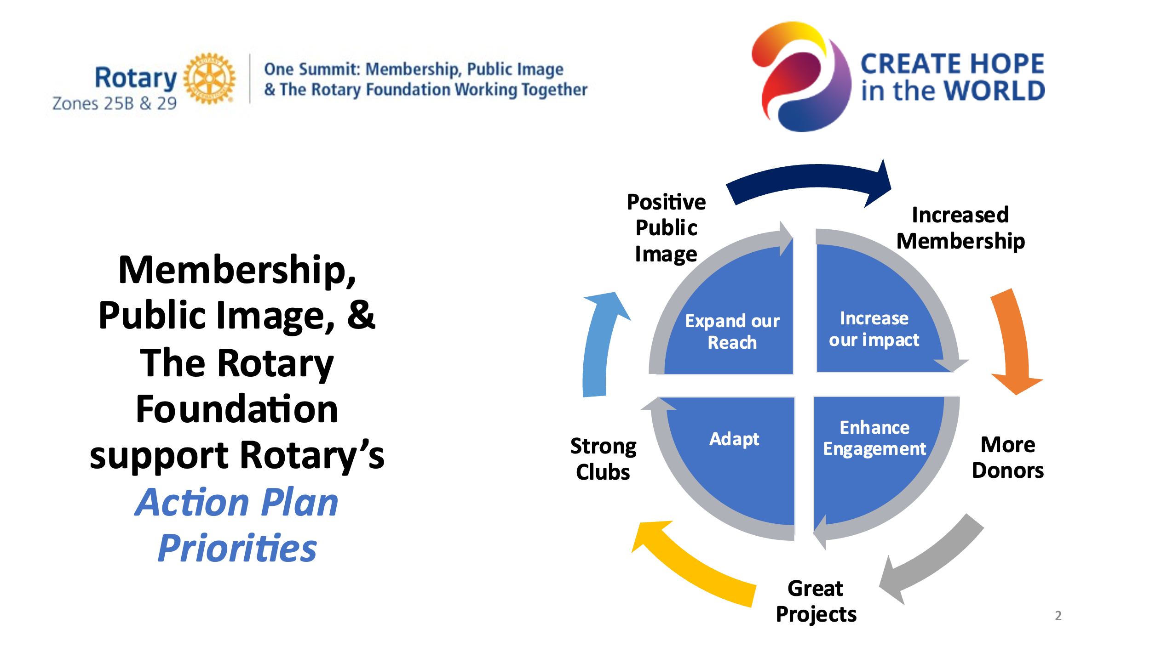

**The synergy of Membership, Public Image, and The Rotary Foundation working together keeps Rotary moving forward by supporting all areas of the Action Plan.**